01.11.2021г. группа 1ТЭМ 2 подгруппа 4 пара
Дисциплина ОДБ.03 Иностранный язык
Преподаватель Романюта Маргарита Вадимовна
Занятие № 17
Модуль 5 «HOLIDAYS»
Тема 5.3 Экология. Загрязнение морского дна.
Тест по материалу модуля 5.
Цели:
• Образовательная – расширение эрудиции студентов, их общего и лингвистического кругозора на основе практического овладения английским языком;
• Практическая–
1. Развитие навыков чтения, устной речи.
2. Совершенствование коммуникативно-познавательной компетенции студентов по теме «».
• Развивающая – развитие языковых, интеллектуальных и познавательных способностей студентов.
• Воспитательная – воспитание у студентов уважительного отношения к окружающей среде.
1.Работа с лексикой
1.1.Прочитайте слова в словаре WL 17 к занятию.
1.2.Запишите в тетрадь слова с транскрипцией.

2.Работа с текстом на стр. 97.

2.1. Read and translate the text « Marine litter».

The terrible truth
We all enjoy a day out at the beach, but these days you are likely to find much more there than just sand and sea! Many of the thousands of people that visit beaches every year leave behind food wrappers, cigarette ends, drink cans and toys like buckets, spades and beach balls. These can then be blown or washed into the sea and become marine litter. Marine litter can also come from ships, fishermen, drains and factories. This litter doesn’t just look horrible – it’s dangerous, too!
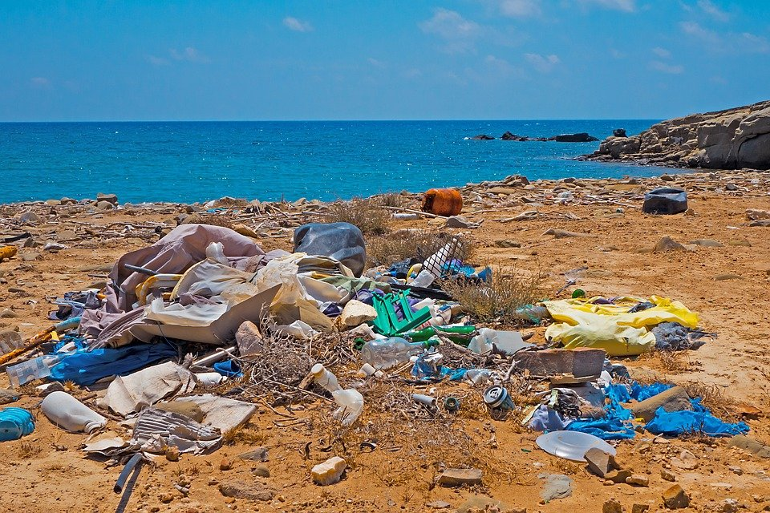
Litter harms Wildlife and People
Marine mammals such as seals, sea lions and dolphins are very curious animals who like to examine unusual objects in the sea.This is how they get mixed up in the litter, which causes them injury and stops them from finding food or swimming away from their enemies. Birds, fish and mammals can also confuse litter for food and eat it. Sea turtles, for example, often eat plastic bags because they look like jellyfish, one of their favourite foods. This then fills up the turtle's digestive system and makes it feel full, so it stops eating and starves. 100,000 marine mammals and nearly a million seabirds die either from getting caught in or eating litter each year! Many of these creatures are already threatened or endangered species. In addition, litter is dangerous for people as they can cut themselves on glass or metal. Marine litter can also block boat propellers, which is dangerous and very expensive to repair.
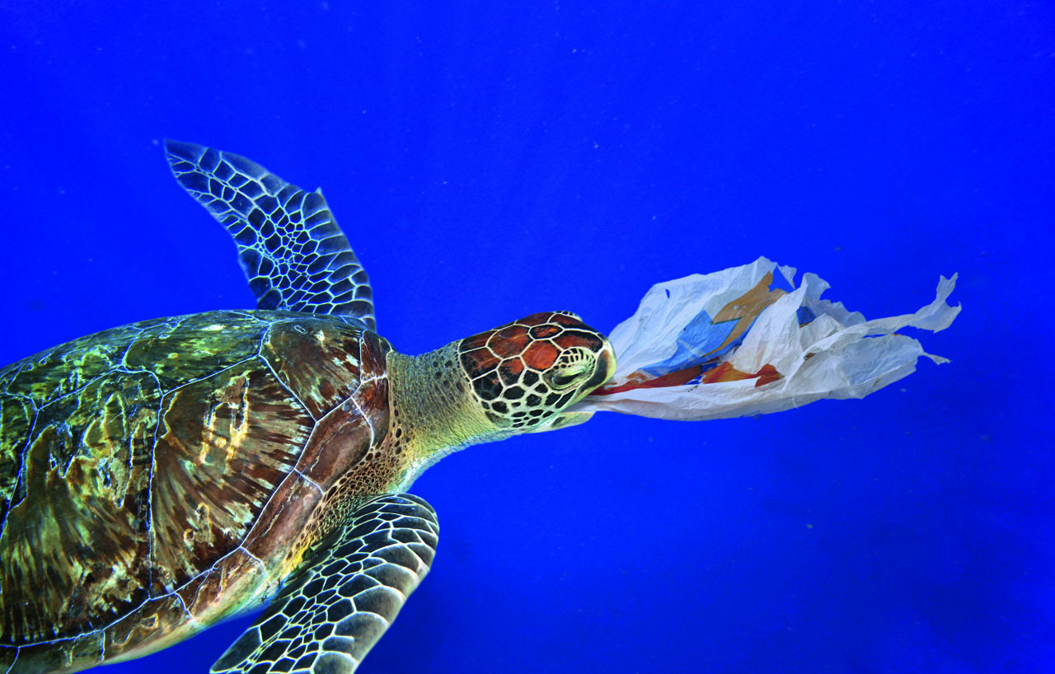
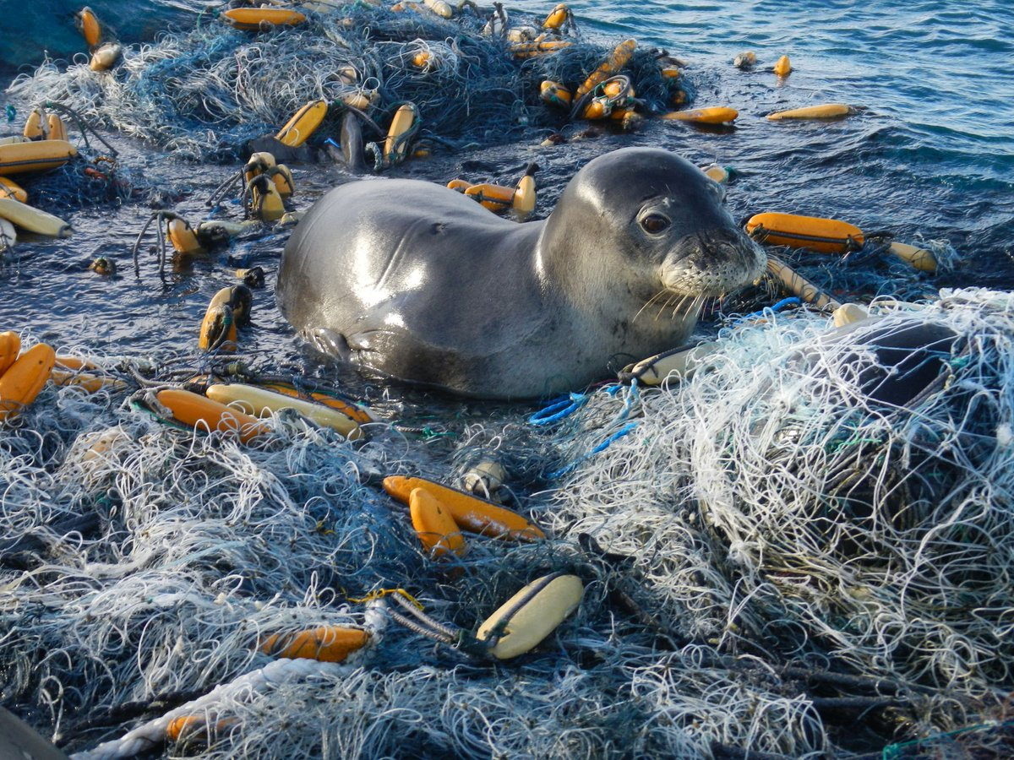
Be the solution
So ... next time you go to the beach, make sure you are part of the solution, NOT the problem! Take ALL of your litter home with you and consider taking any other litter you can see around you too. If you live near a beach, you could even organise a Beach Clean-up Day.
2.2.Answer the questions, then explain the words in bold. Then, tell your partner three things...
1. What is marine litter?
2. In which two ways does marine litter harm wildlife? Why?
3. How can litter harm people?
4. List three ways we can help solve the problem.
3. Лексическое упражнение.
1. Fill in: vendors, tour , town , bus, travel, shade, peaks .
1. Here is the ... of Pompeii.
2. There's a beautiful view of the snowy ... of the mountains from our hotel room.
3. This part of town is full of street ... .
4. We went on a guided ... of London.
5. You can take the local .... to get to the city centre.
2. Choose the correct answer A, B or C.
1. How are you going to get ………. in the city?
A at B around C through
2. How do you get ……… your classmates?
A on with B up C off
3. The underground is the most convenient form of ………. in the city.
A transfer B transport C touring
4. I prefer going to school .... foot .
A by B on C off
5. My parents always hire/rent a tour guide when they go abroad.

Домашнее задание:
1.Письменно выполнить упражнение 2.2. данного занятия.
2.Выполнить тест по материалу Модуля 5.
1. Translate Russian words in English.
1 ) захватывающий дух
2)экскурсия, организованная поездка
3)не получаться, сорваться
4)отправиться в путь
5)порт захода
6)шезлонг
7)сводить концы с концами
8)граница
9)багаж
10)ладить с кем-либо
2.Choose the correct variant.
11) At 5 o’clock yesterday evening they ___________ in the pool.
a) were swimming b) swam c) was swimming
12) Marry __________ her homework from 2 till 5 o’clock.
a) has doneb) did c) was doing
13) Ann ________ pancakes whole morning.
a) had cooked b) cooked c) was cooking
14) Yesterday evening she _____ to the gym.
a) had gone b) went c) was going
15) Jack London _______ many novels.
a) wrote b) was writing c) writting
3. Open the brackets and put the verb in the correct form.
16)They (go) to the cinema after they (return) from school.
17) We (wait) for two days before Alex (call) us.
18)Sam (miss) the train , so she ( be) very upset.
19) Kate (clean) the house while Tom (wash) his car.
20)When we (come) into the classroom, the teacher (write) on the blackboard.
4.Fill in the blanks with the following articles: a/an, the or zero articule.
21) You were such ____ clown yesterday.
22) Both ___ pens are not working.
23) It’s quite ___ long way.
24) I see ___ man waving. I see ____-people waving.
25) ____ only question I have is how much I will be paid.

Срок выполнения задания до 08.11.2021.
Все работы выполнять в рабочих тетрадях, фотографировать и отправлять на адрес преподавателя Романюты М.В. rita.romanyuta@mail.ru
Используемая литература:
1. Афанасьева О.В., Дули Дж., Михеева И.В., Оби Б., Эванс В. УМК «Английский в фокусе» для 10 класса, М.: Просвещение; UK.: Express Publishing: 2018;
2. Агабекян И. П., Коваленко П. И. Английский для технических вузов. Феникс, Ростов-на/Д, 2009.
Дополнительные источники:
- Ионина И., Саакян А. Английская грамматика. Теория и практика. – М.: Академия, 2008.
- Бережная О. О. Сборник новых тем современного английского языка. Донецк, 2009.
Справочники:
- Мюллер В. К. Англо-русский и русско-английский словарь. – М.: ЭКСМО, 2010.
Интернет-ресурсы:
- Портал по изучению английского языка.
Форма доступа: http//www.englishlanguage.ru.
- Сайты для изучения английского языка.
Форма доступа: http://www. study.ru – English Info
http://www.native-english.ru
http://www.study.ru
http://www.homeenglish.ru

